Full facility name: | Date of test: | Test Completion Date:
Overall organization/project AIM:
What is the objective of the test?
PDSA WORKSHEET
Do
Study
Act
Plan

PLAN:  Briefly describe the test:  How will you know that the change is an improvement?  What driver does the change impact?  What do you predict will happen?  PLAN  List the tasks necessary to complete this test (what) Person responsible (who) When Where  1.  2.  3.  4.  5.  6.  Plan for collection of data: | DO: Test the changes.  Was the cycle carried out as planned? ⁪ Yes ⁪ No  Record data and observations.  What did you observe that was not part of our plan?  STUDY:  Did the results match your predictions? ⁪ Yes ⁪ No  Compare the result of your test to your previous performance:  What did you learn?  ACT: Decide to Abandon, Adapt, Adopt  Abandon: Discard this change idea and try a different one.  Adapt: Improve the change and 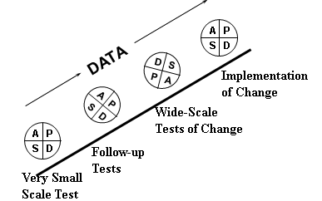  continue testing plan. Describe what you will change in your next PDSA:  Adopt: Select changes to implement on a larger scale and develop an implementation plan and plan for sustainability  If you plan to adopt, what plans do you have for your next 2 - 3 PDSA cycles  for follow-up tests and implementation:

