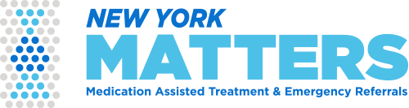
In support of Collaborative participants’ efforts to provide timely referral and continuation of care for individuals with opioid use disorder (OUD) in the emergency department (ED), GNYHA Foundation, with the support of Mother Cabrini Health Foundation, is pleased to provide 2 iPad tablets to connect participating hospitals to NY MATTERS electronic referral platform.

NY MATTERS Program provides hospitals:
- Access to an electronic referral platform, hosted by the New York State Department of Health, to efficiently refer patients with OUD using a tablet to participating community-based providers

- Vouchers that cover up to 14-day of buprenorphine/naloxone prescription for uninsured patients at major pharmacies and certain independently owned pharmacies
- Implementation and technical support from NY MATTERS

To receive 2 iPad tablets for NY MATTERS referral and prescription resources complete the below delivery information and email to Catrina “Cat” Caneda, ccaneda@gnyha.org, using “ED MAT – NY MATTERS Program and Referral Tablets Form” in the email subject line.
Health System and Facility
Name of Health System:
Name of Hospital Facility:
Point of Contact
Name:
Job Title:
Phone #:
Email:
Receiving Address:
Address:

Phone #:

